Organization and Architecture Computer

Multiplication Assignment



Tri Utomo

L200154006

X Class

Universitas Muhammadiyah Surakarta

1. Q = 10, M =12

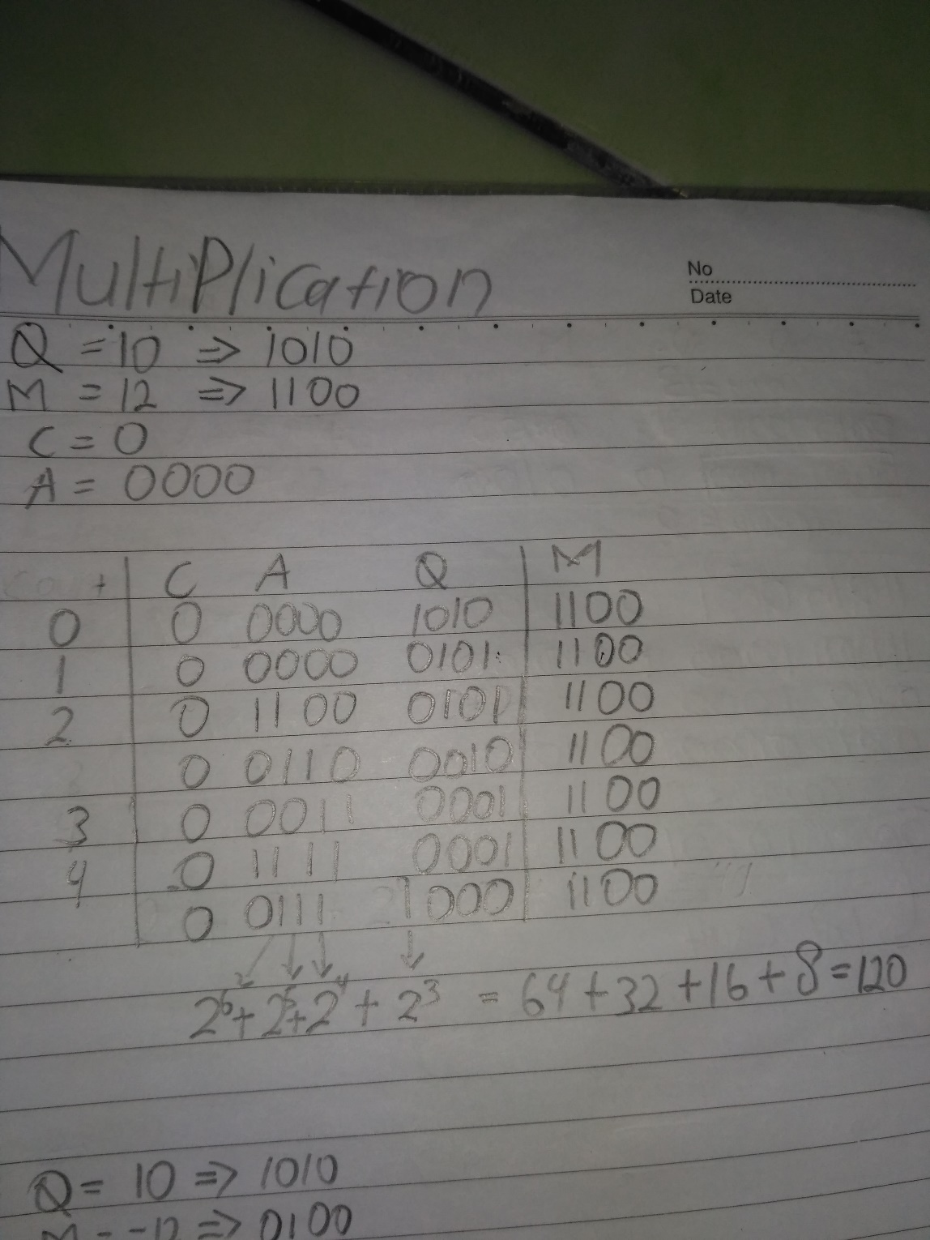

1. Q = -10, M = 12

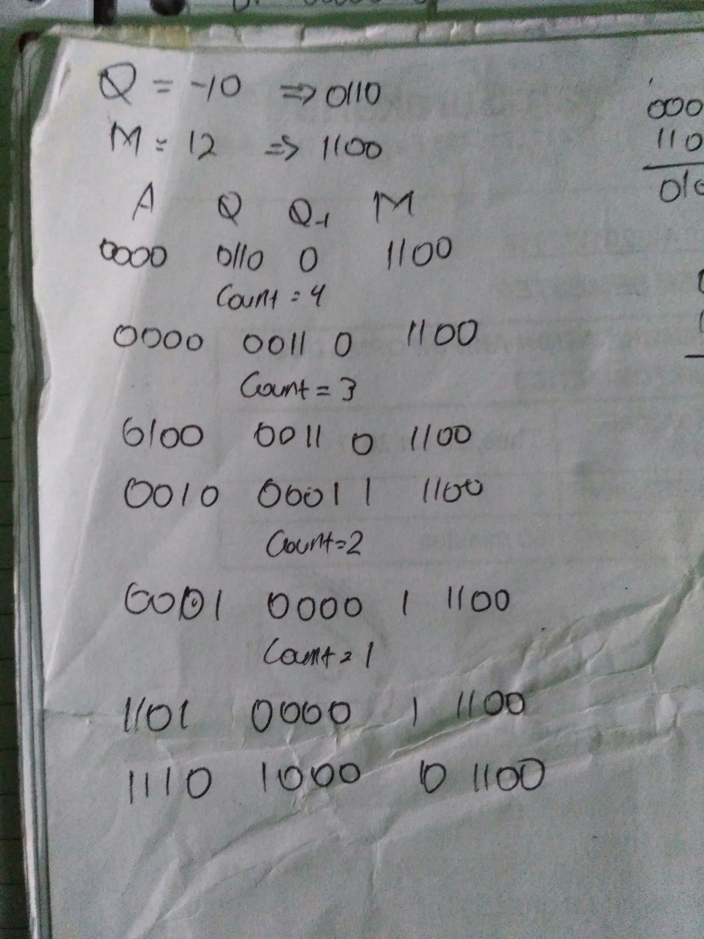

1. Q = -10, M = -12

